FIT2179 Data Visualisation 2 Submission
From Sky to Tap: Victorian Water Security Under Climate Stress
Name | Divyanshu Sharma
Student ID | 36145335
Studio Session | TO COMPLETE: enter studio session

Part A: URL of the Visualisation
Paste your visualisation URL in the empty space below.
https://div3-333.github.io/FIT2179-DV2-36145335/

Part B: Domain Description

Describe your domain chosen for DV II
From Sky to Tap examines Victorian water security under compounding climate stress: rainfall deficit, rising maximum temperature, evaporation, reservoir response, groundwater pressure and desalination. The domain is deliberately Australian and public-facing. It treats water security as a linked climate-infrastructure system, showing how atmospheric conditions move from sky, to catchment, to storage, and finally to engineered supply.

Describe the Why and Who aspects of your DV II
Using Munzner's Why level, the visualization primarily presents, compares and connects evidence rather than acting as an expert analytics tool. It asks where rainfall stress is concentrated, how the temperature baseline has shifted, how climate drivers and evaporation intensify storage pressure, and when desalination becomes a meaningful buffer. The audience is the average Australian viewer: someone familiar with drought, reservoirs and water restrictions, but not expected to know hydrology, ENSO terminology or statistical modelling.

Describe the "What" aspect of your DV II
Using Munzner's What level, the project combines spatial, temporal and tabular public datasets from the Bureau of Meteorology, ACORN-SAT, SILO, Melbourne Water, Victorian water planning material, groundwater bore records and Victorian Water Accounts. The attributes include rainfall deficits, monthly maximum temperature, SOI, evaporation, rainfall, reservoir capacity and percentage full, bore-permit density, resource-use volumes, desalination delivered and urban demand. Derived fields are used transparently: rainfall anomalies, historical/modern temperature windows, an OLS evaporation trendline, normalized resource shares, desalination dependency ratios, spatial interpolation, grid density and storage-desalination state positions.

Describe the "How" aspect of your DV II
Using Munzner's How level, the site uses a single scrolling Vega-Lite narrative with maps, heatmaps, line charts, composite bars, scatter/regression, normalized stacked bars, area charts and a bivariate resilience matrix. Position encodes ordered quantitative values; size encodes magnitude where scale matters; colour is reserved for intensity, category or highlighted story evidence. Tooltips, annotations, pan/zoom controls, sliders, filters, selectors and a linked 2021+ toggle let viewers test the story without losing the guided structure. The methodology ledger documents sources, transformations and idiom rationale, and generative AI assistance is acknowledged for coding, writing polish and audit support.

Part C: Sketch
A URL to a PDF document with an image of your sketch on your GitHub account.
https://github.com/Div3-333/FIT2179-DV2-36145335/blob/main/sketch.pdf

Paste a screenshot of your sketch for your DV II.
Note: The sketch is split across two pages so it remains clearly legible at submission scale.
Sketch screenshot (part 1 of 2)
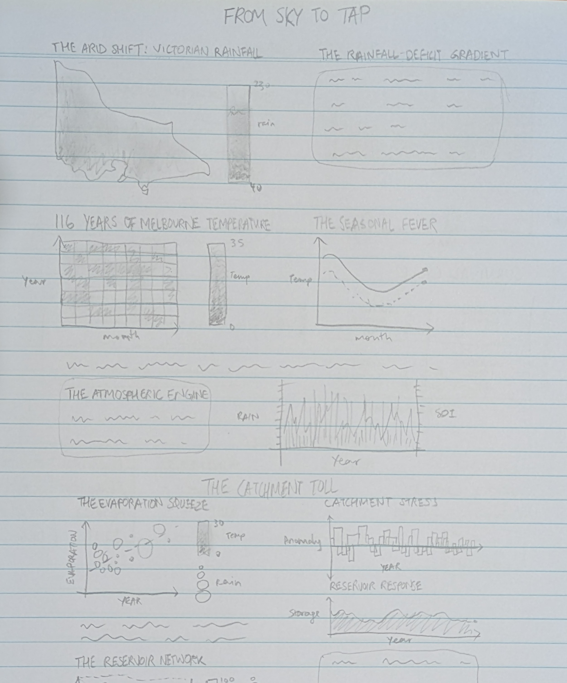

Sketch screenshot (part 2 of 2)
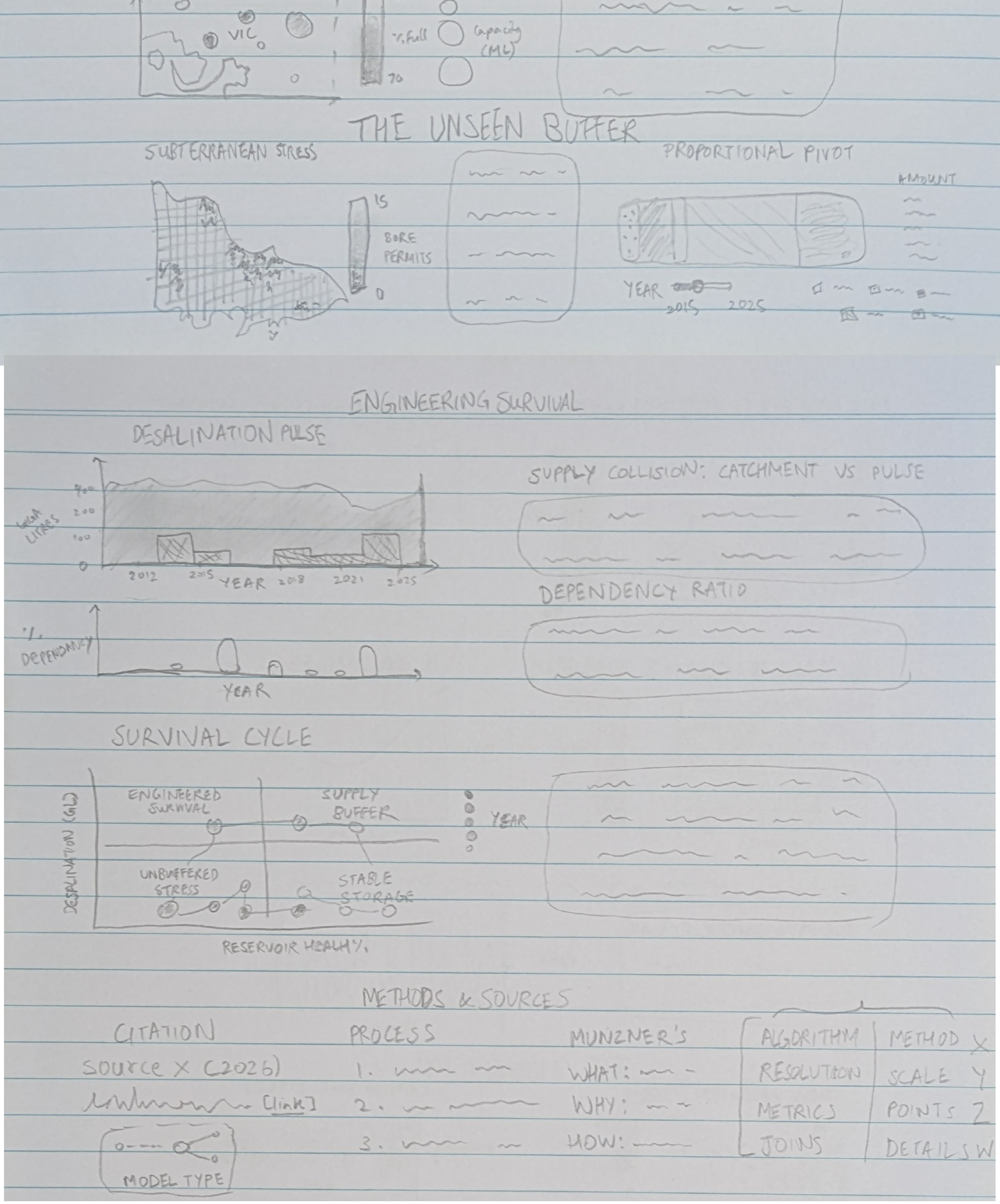

Part D: Full-size screenshot of your DV II
Paste a full-size screenshot of your DV II assignment from the URL here.
The full-page website screenshot is sliced vertically for readability; together these panels form one continuous screenshot.
Full-size website screenshot (part 1 of 8)
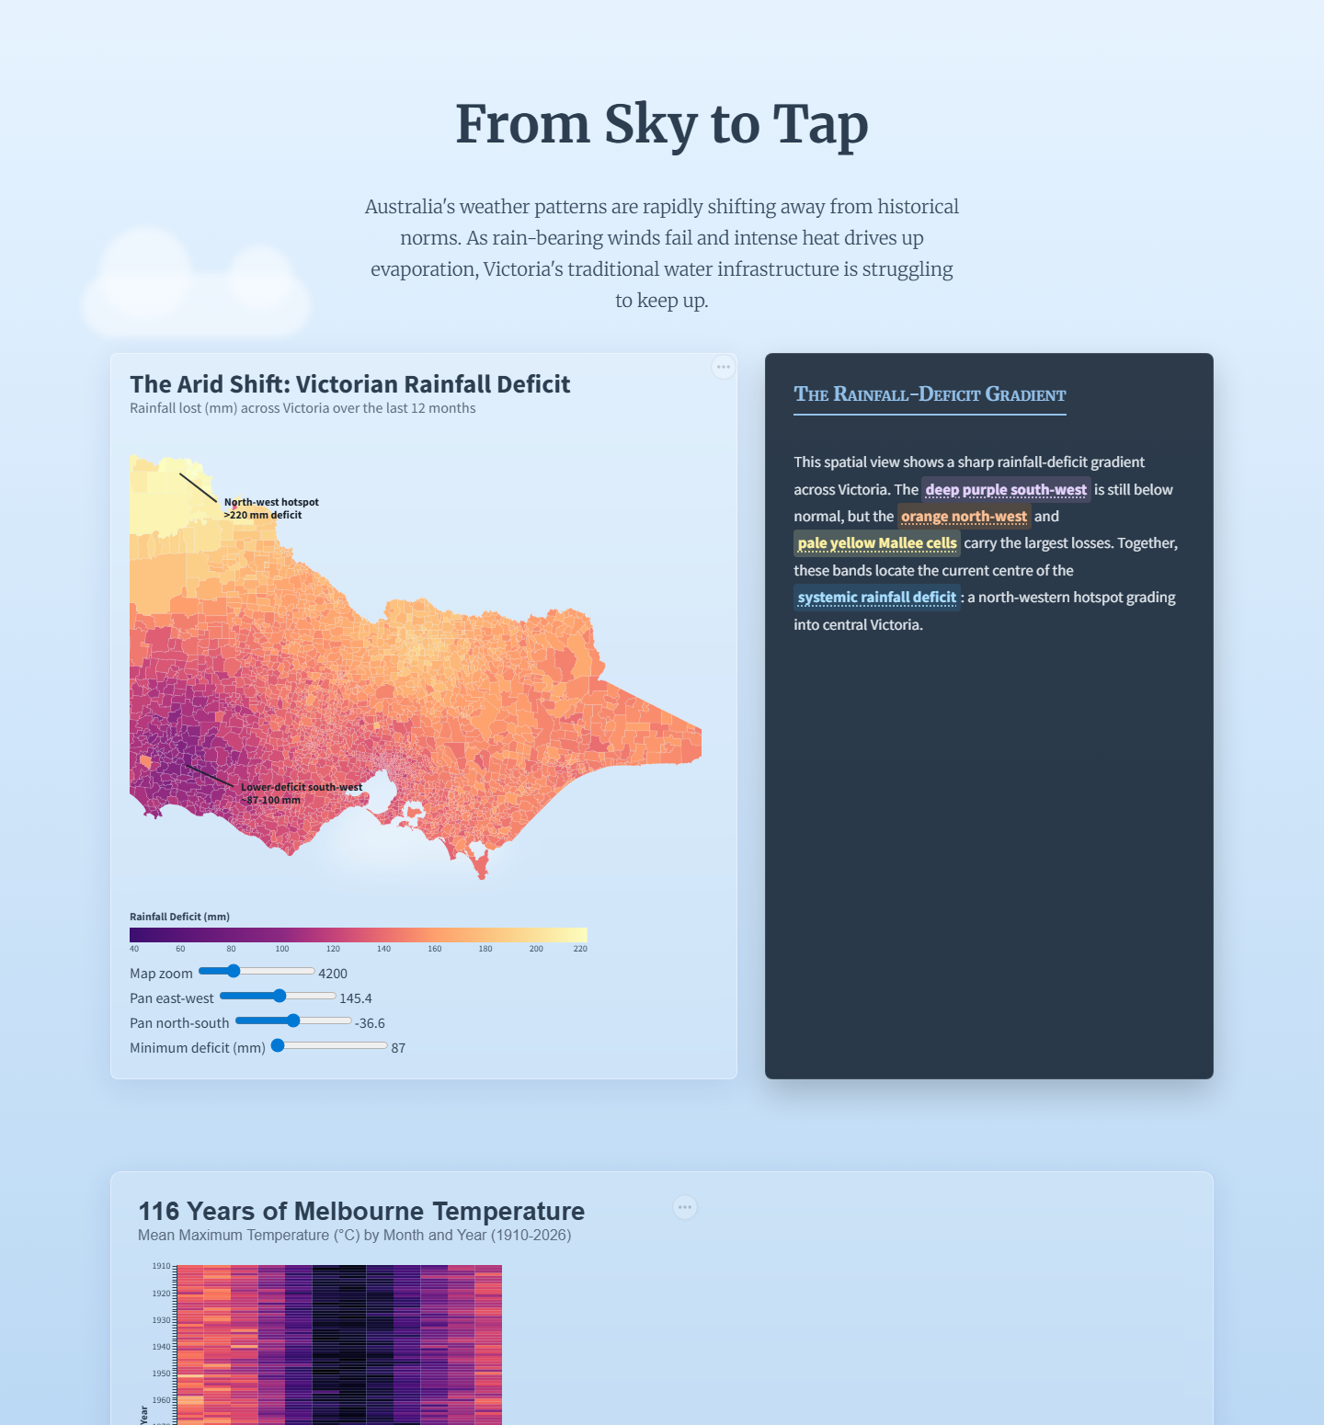

Full-size website screenshot (part 2 of 8)
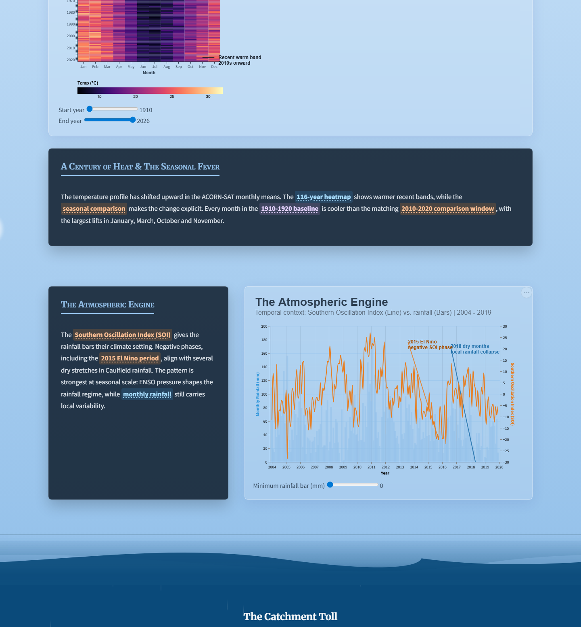

Full-size website screenshot (part 3 of 8)
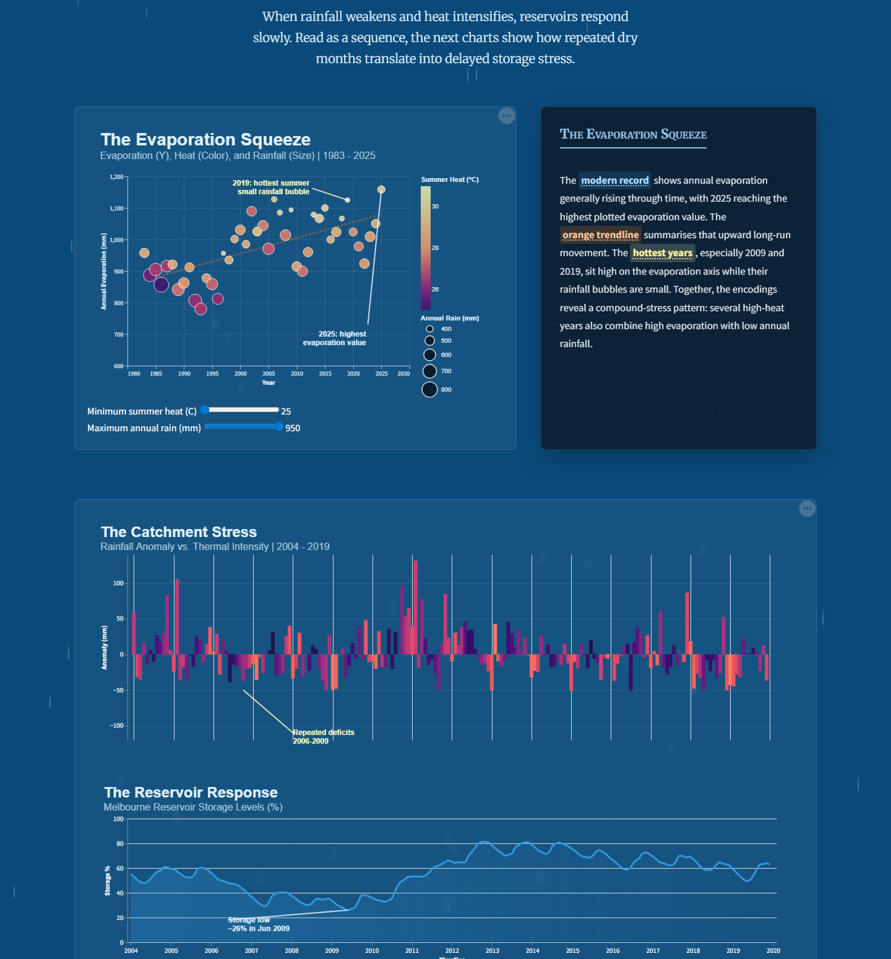

Full-size website screenshot (part 4 of 8)
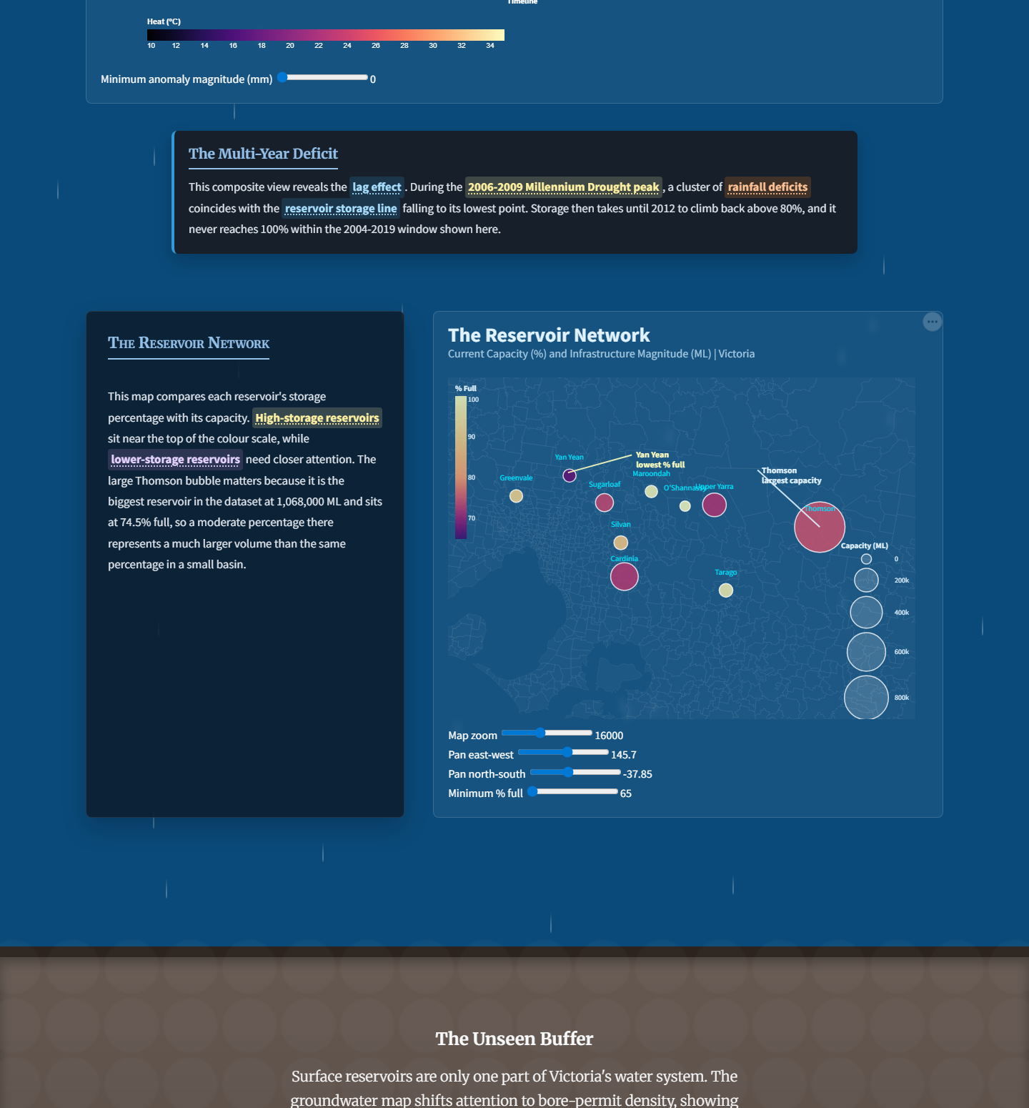

Full-size website screenshot (part 5 of 8)
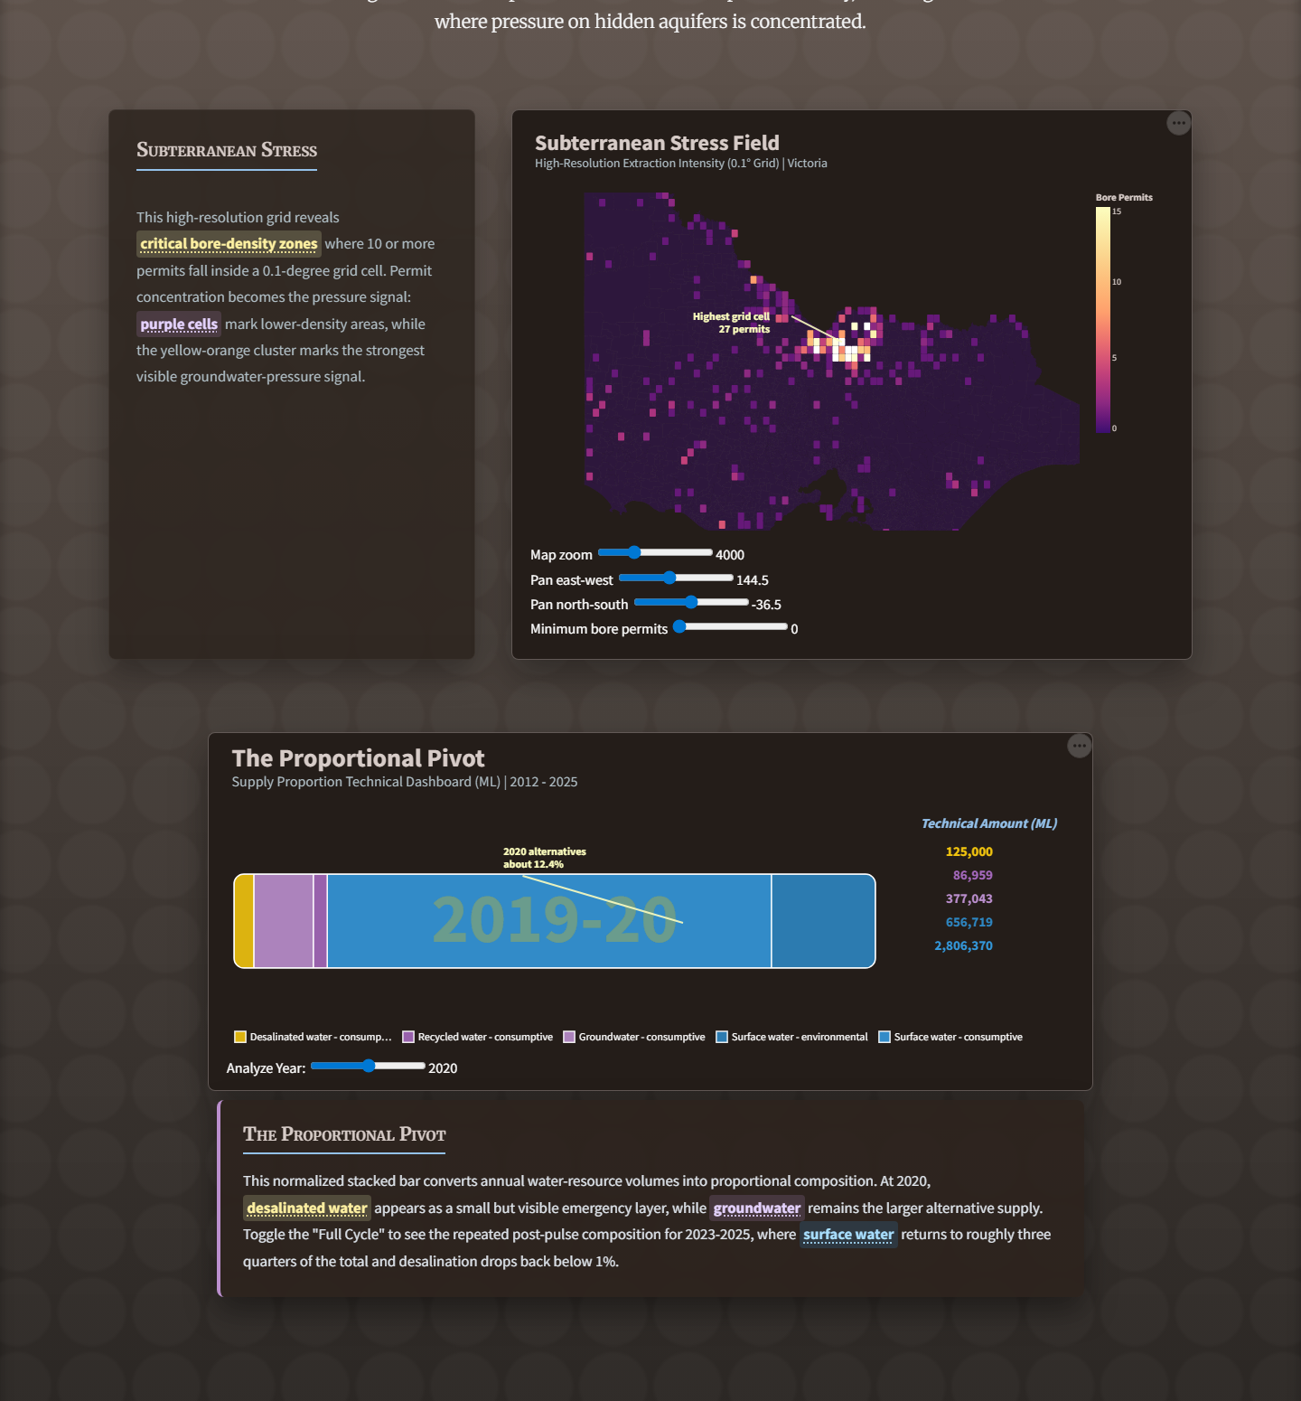

Full-size website screenshot (part 6 of 8)
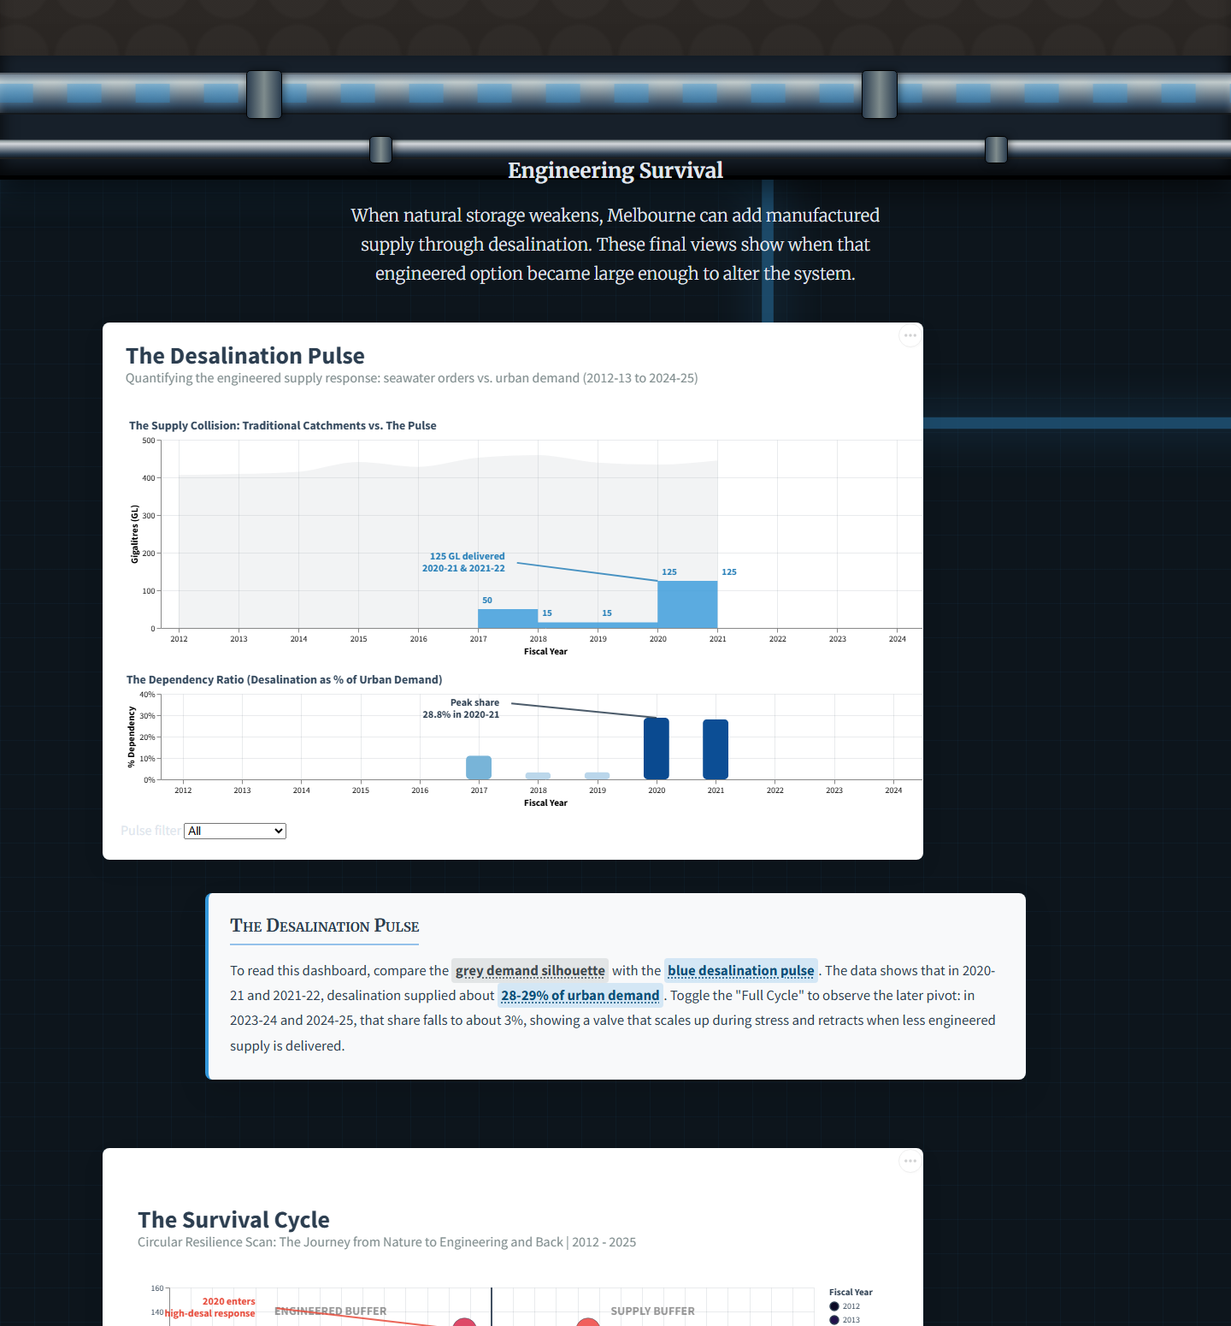

Full-size website screenshot (part 7 of 8)
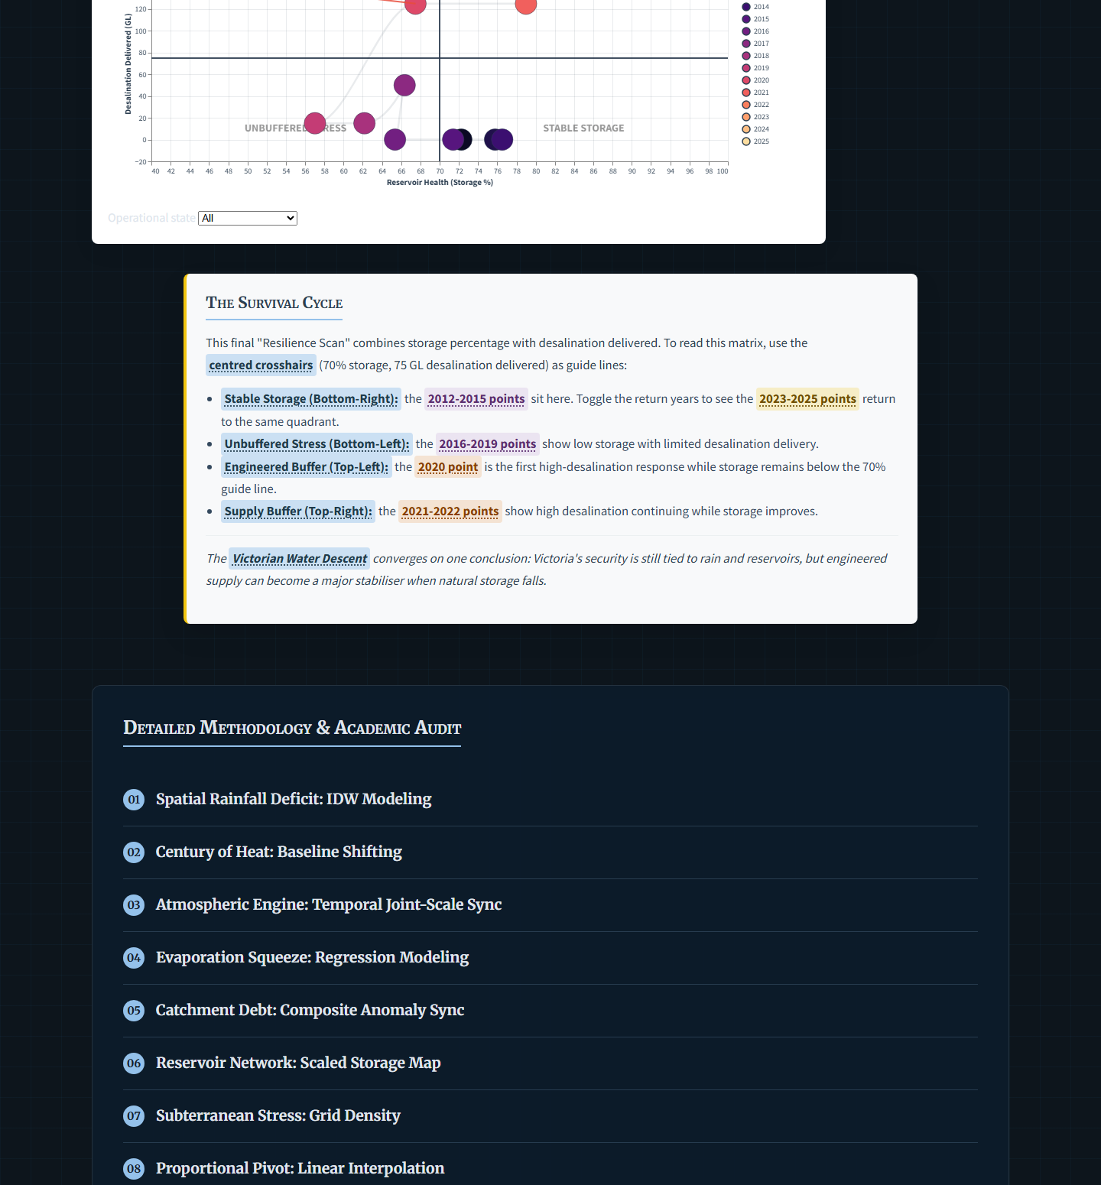

Full-size website screenshot (part 8 of 8)
